Leo Turbet-Delof4:53 PM
How could we provide the stars feature?
Atul Sood4:57 PM
For the rating feature, we need to store the ratings in the database. If we don’t want to store them in our database, then we’ll need to integrate a third-party tool.
Do it natively in Payload.
It’s the cleanest solution for your blog.
Here’s the setup I recommend:
collection: recipeRatings
denormalized fields in recipes: ratingAverage, ratingCount
voting via endpoint/API or server action
duplicate prevention via logged-in user or cookie + IP hash
ultra-simple Astro display
What do you think about this ?
Atul Sood5:05 PM
Yes, that approach looks great and makes sense.
Just to clarify for duplicate prevention — should we implement user authentication, or do you prefer using cookies + IP hash only?
I can proceed accordingly.

Leo Turbet-Delof5:06 PM
For duplicate prevention, we prefer cookies + IP hash only for now, without user authentication. Since this is a recipe blog, we want to keep the rating flow frictionless. A lightweight visitor-based approach should be enough at this stage, and we can always move to authenticated voting later if needed.
Atul Sood5:08 PM
Got it, that sounds perfect
We’ll proceed with a lightweight approach using cookies + IP hash for duplicate prevention, keeping the rating flow simple and frictionless.

9. WORKSHOPS BLOCK
Cooking workshops
I welcome you to cooking and pastry classes in a friendly environment, with a precise, generous, and accessible approach.
Each workshop is designed to truly learn, practice, understand techniques, and leave with solid skills.
I also work with companies: team-building events, gastronomy clubs, and custom training for private groups.
- Button: View workshops

10. VIDEO COURSES BLOCK
My video courses
Discover my first video courses to learn pastry basics at your own pace from home.
Pastry cream, whipped cream, diplomate cream, millefeuille, inverted puff pastry—essential techniques explained step by step with the right methods, textures, and details to succeed.
- Primary button: View video courses
- Secondary button: Discover the bundle

11. VIDEO CARDS
- Pastry cream – The essential base of French pastry
- Whipped cream – Stable, perfectly mastered whipped cream
- Diplomate cream – A delicate mix of pastry cream and whipped cream
- Millefeuille – Step-by-step assembly of a classic dessert
- Inverted puff pastry – A professional technique made accessible
(Each with button: View course)

12. VIDEO BUNDLE BLOCK
The pastry basics bundle
A complete set of essential preparations to progress step by step: pastry cream, whipped cream, diplomate cream, inverted puff pastry, and millefeuille assembly.
Designed as reusable foundations to improve skills and apply them to many desserts.
- Button: Discover the bundle

New Changes
Leo Turbet-Delof11:00 PM
Vertical Space on mobile are not there
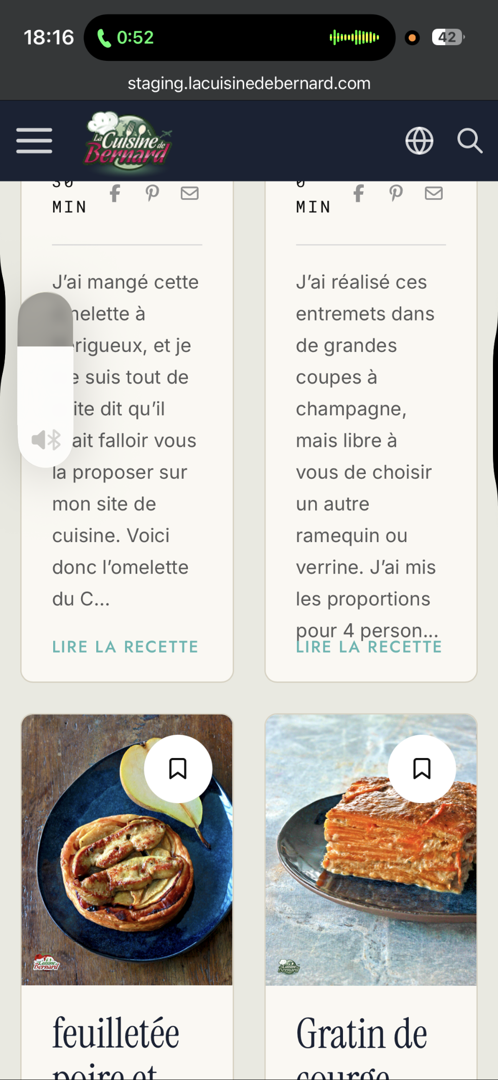

Padding issue with title
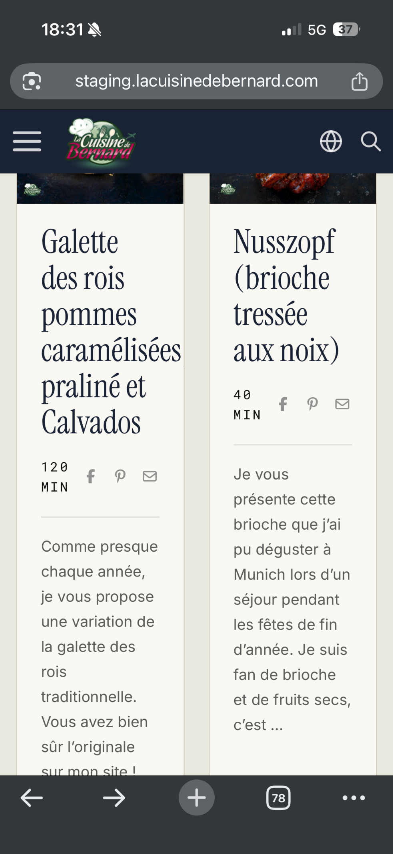

Temps de préparation issue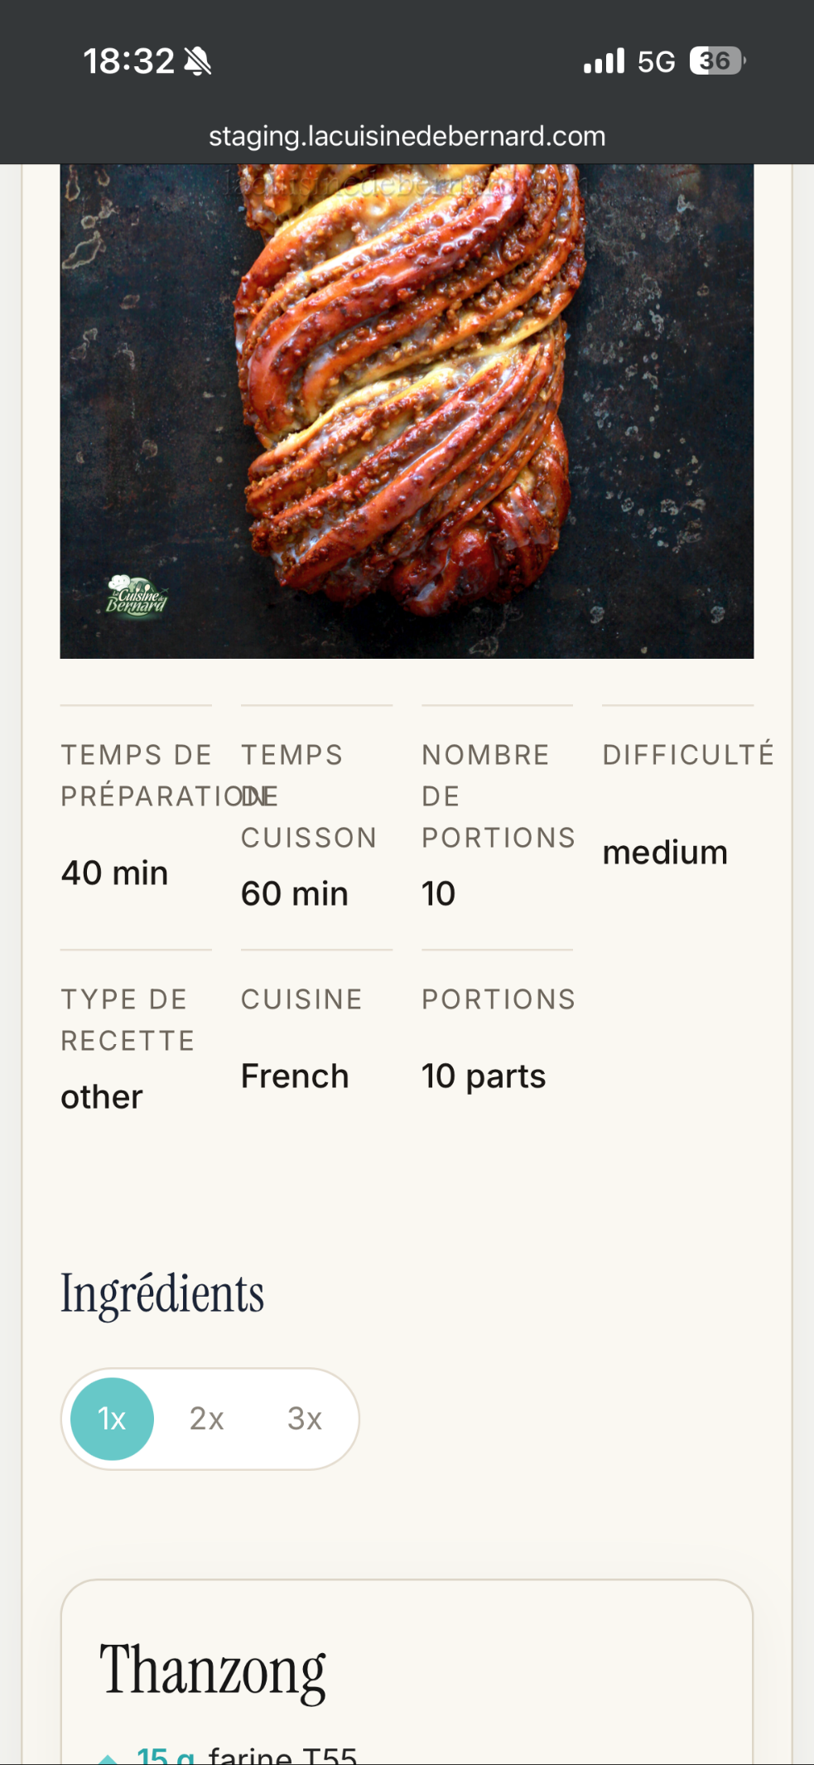

Issue with English
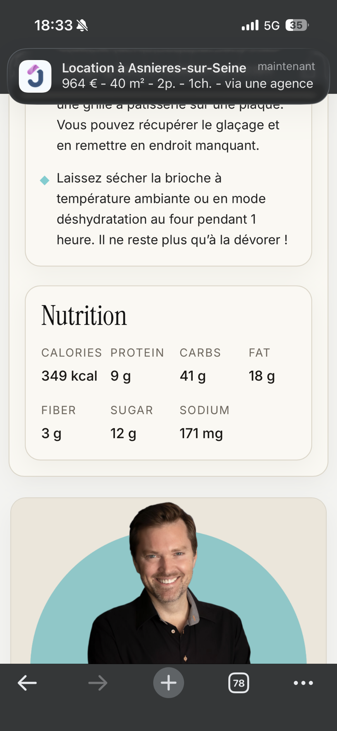

We still have English here too